A: Reproduction and Meiosis
- a) Outline the stages involved in making pollen in the anthers of a strawberry plant. (4)
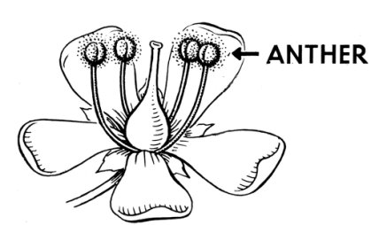
.......................................................................................................................................

.......................................................................................................................................

.......................................................................................................................................

.......................................................................................................................................

.......................................................................................................................................

.......................................................................................................................................

b) The mass of DNA in the nucleus of a pollen cell is 0.25micrograms (µg). (4)
i) What will the mass of DNA be inside the nucleus of an unfertilised egg cell?
.......................................................................................................................................

.......................................................................................................................................

ii) What will the mass of DNA be inside a fertilised cell nucleus?
.......................................................................................................................................

.......................................................................................................................................

iii) What will the mass of DNA be inside the nucleus of an anther cell in grams?
.......................................................................................................................................

.......................................................................................................................................

iv) What will the mass of DNA be in an anther cell nucleus prior to cell division?
.......................................................................................................................................

.......................................................................................................................................

- a) Why do most organisms have even numbers of chromosomes in their body cells? (2)

.......................................................................................................................................

.......................................................................................................................................

.......................................................................................................................................

b) What happens to the chromosomes in the nucleus of an ovary cell when it forms egg cells? (3)

.......................................................................................................................................

.......................................................................................................................................

.......................................................................................................................................

- After the sperm and the egg nuclei fuse, the fertilised egg is known as a zygote. The single cell of the zygote divides every 15 hours to form two cells. These cells continue to divide every 15 hours to formm a ball of cells known as the embryo.
Calculate how long it will take in hours from fertilisation to the formation of a ball of 32 cells. (1)
.......................................................................................................................................

.......................................................................................................................................

.......................................................................................................................................

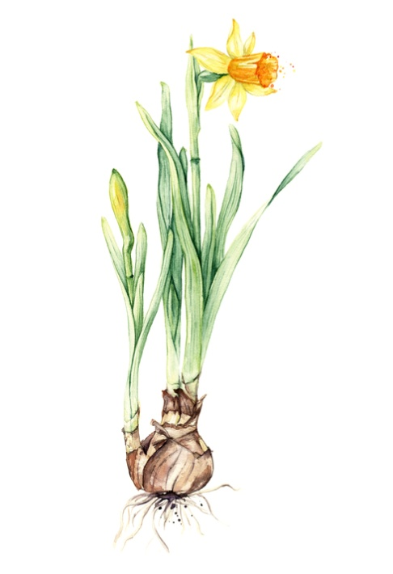
Biology only question

Extended response question:

- Daffodils can reproduce both sexually and asexually.
Flowers produce gametes (pollen and eggs) which create seeds if fertilisation is successful.
A daughter bulb grows from a bud at the base of a parent bulb. This will generate a new plant.
Explain the advantages and disadvantages of sexual and asexual reproduction for the daffodil. (6)

.......................................................................................................................................

.......................................................................................................................................

.......................................................................................................................................

.......................................................................................................................................

.......................................................................................................................................

.......................................................................................................................................

.......................................................................................................................................

.......................................................................................................................................

.......................................................................................................................................

.......................................................................................................................................

.......................................................................................................................................

.......................................................................................................................................

B: Genetic inheritance, inherited disorders and sex determination
- Hitch hiker’s thumb is a genetically inherited condition caused by a dominant allele, T. 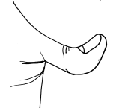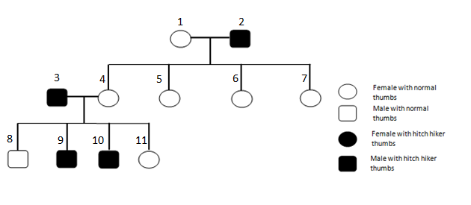
.

- What is the genotype of person 1?

.......................................................................................................................................

.......................................................................................................................................

.......................................................................................................................................

- What is the phenotype of person 4 in relation to gender and thumb type? (1)

.......................................................................................................................................

.......................................................................................................................................

.......................................................................................................................................

- Describe the genotype of parents 3 and 4. (1)

.......................................................................................................................................

.......................................................................................................................................

.......................................................................................................................................

- Explain how their offspring 9 and 10 have inherited hitch hiker thumbs, yet 8 and 11 have not. Complete the Punnett square diagram to show the possible offspring if 3 and 4 mated. (6)

.......................................................................................................................................

.......................................................................................................................................

.......................................................................................................................................

- Mary has a genetic condition called cystic fibrosis which is a disorder of cell membranes. Mary is homozygous recessive for the condition. Her sister is heterozygous and is healthy.
She and her husband John want to have children in the future. John is healthy but he does not want to know his genotype. Explain why it would be helpful for John’s genotype to be known. (3)

.......................................................................................................................................

.......................................................................................................................................

.......................................................................................................................................

.......................................................................................................................................

.......................................................................................................................................

.......................................................................................................................................

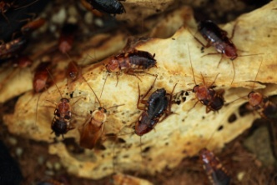
- Male cockroaches only have one sex chromosome.
Their genotype is XO where O means there is no chromosome present.
Female cockroaches have the genotype XX

Complete the genetic diagram to show the possible genotypes and phenotypes of the offspring from two cockroaches. One has been done for you. (5)

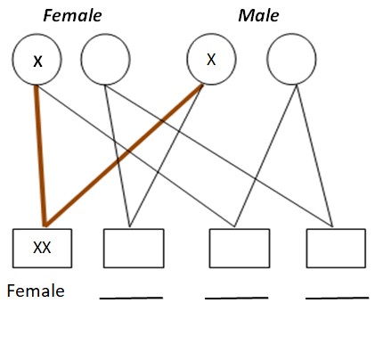

C: DNA and protein synthesis
1 a) Complete the diagram of a DNA molecule by adding in the correct complementary bases. (3)

G | A |  |  | C |  |  |  | G
 |  | T | C |  | A | T | G |  | A
b) Annotate the diagram of the DNA polymer below with the following 4 labels: (4)
base common sugar phosphate group nucleotide
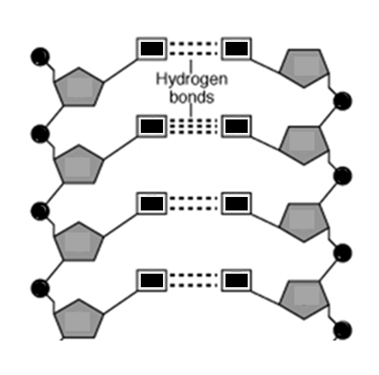

c) Explain why DNA is described as a polymer. (2)
.......................................................................................................................................

.......................................................................................................................................

.......................................................................................................................................

Biology Only Question
Extended response question
- Mutations occur continuously and on rare occasions some mutations result in an altered protein with a different shape being produced.
The mutation which results in cystic fibrosis results in bases being deleted.

Normal sequence of nucleotides:
A T C A T C T T T G G T G T T
Mutated sequence of nucleotides:
A T C A T T G G T G T T

In people without cystic fibrosis, the protein made functions as a channel across the membranes of cells which produce mucus. Chloride ions pass in and out of cells through this channel and aid the movement of water which is required to produce thin freely flowing mucus. This protein channel does not function in cystic fibrosis due to the changed shape of the protein produced.
- Explain how this mutation would result in an altered protein being made which does not fold properly and so does not function. (6)
.......................................................................................................................................

.......................................................................................................................................

.......................................................................................................................................

.......................................................................................................................................

.......................................................................................................................................

.......................................................................................................................................

.......................................................................................................................................

.......................................................................................................................................

.......................................................................................................................................

.......................................................................................................................................

.......................................................................................................................................

.......................................................................................................................................

- If there was genetic variation in the non coding part of a gene, how could this affect the phenotype? (3)
.......................................................................................................................................

.......................................................................................................................................

.......................................................................................................................................

D: Variation, mutation and the human genome project
- Sweet potato plants produce tubers.
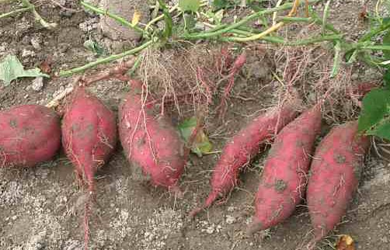
Tuber of sweet potato
A gardener uses some of the tubers for food and some to produce sweet potato plants.
The tubers are produced by asexual reproduction.
The gardener plants the tubers in different parts of the garden. She noticed that the plants did not all grow to become the same height despite having the same genome. Suggest two reasons why this has happened. (2)
.......................................................................................................................................

.......................................................................................................................................

.......................................................................................................................................

- These trees are all the same species.
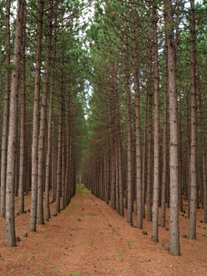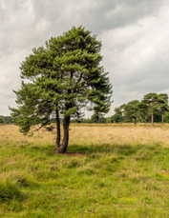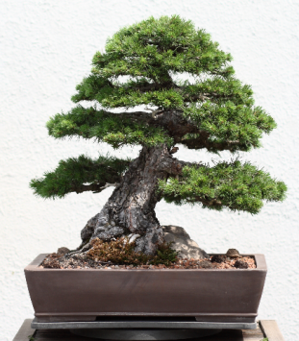
Scots Pine bonsai tree
Scots Pine plantation
Scots Pine in a field
25m
300mm
35m

- Convert the height of the bonsai tree into metres. (1)
.......................................................................................................................................

.......................................................................................................................................

.......................................................................................................................................

- What is the simplest ratio of height between the plantation tree and the field tree? (2)
.......................................................................................................................................

.......................................................................................................................................

.......................................................................................................................................

- What is the major cause of variation between these trees? (1)
.......................................................................................................................................

.......................................................................................................................................

.......................................................................................................................................

- If the Bonsai tree was planted outside in a field would it grow larger? Explain your answer. (2)
.......................................................................................................................................

.......................................................................................................................................

.......................................................................................................................................

- The lake in the picture was home to a large population of fish of the same species. Over a long period of time, the lake reduced in size and formed two smaller lakes.
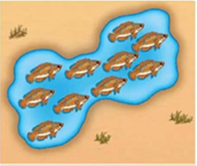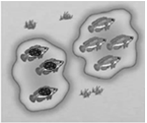
In the winter of 2013 there was a lot of rainfall and the two lakes merged back into one.
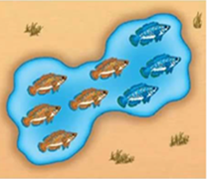
Fishermen noticed that there seemed to be two different phenotypes of fish in the lake. Scientists found that two new species had been formed.
Explain how this has occurred. (5)
.......................................................................................................................................

.......................................................................................................................................

.......................................................................................................................................

.......................................................................................................................................

.......................................................................................................................................

.......................................................................................................................................

.......................................................................................................................................

.......................................................................................................................................

.......................................................................................................................................

- a) Suggest two ways in which the Human Genome Project (HGP) may improve the medical care for the future. (2)

.......................................................................................................................................

.......................................................................................................................................

.......................................................................................................................................

- Suggest two ways in which the HGP may have a negative effect on people. (2)
.......................................................................................................................................

.......................................................................................................................................

.......................................................................................................................................

